Contact App

## Synchronization of User Contacts

In order to achive US064, users must be able to syncronize contacts between Android and Alfred systems. The application ContactApp has been developed to allow this.

### Requirements:

ContactApp requires the presence of ALFRED Profile, so a user of Alfred is already logged in the system. In case this is not satisfied, a message will appear when starting ContactApp.

Be sure first to have your ALFRED Profile logged like this:

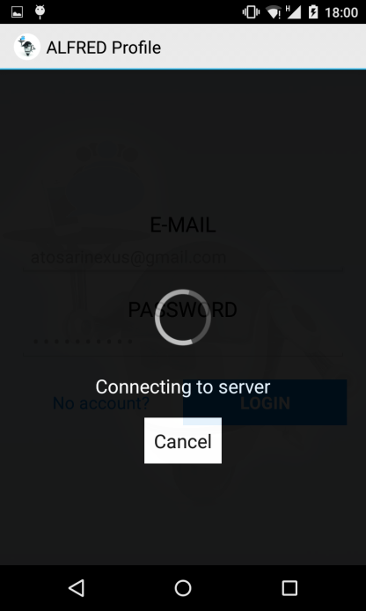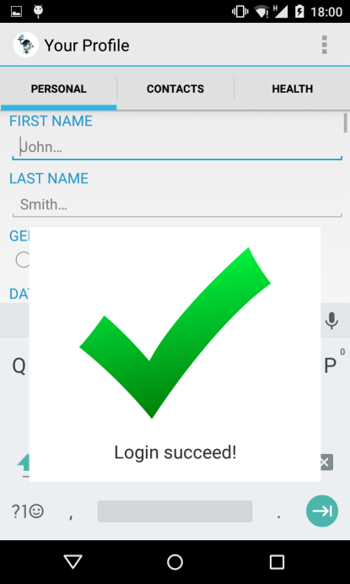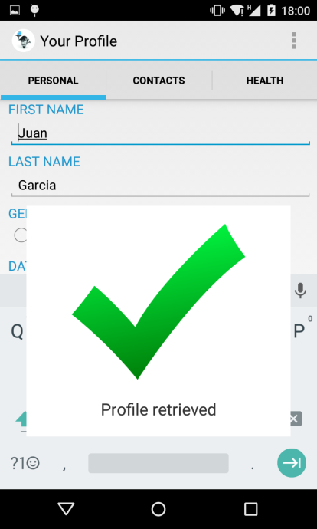

Internet connection is also required to allow the retrieval of Alfred contacts and the update or insertion as a result of the synchronization. The app establishes the following permissions:

<uses-permission android:name="android.permission.READ\_CONTACTS"/>

<uses-permission android:name="android.permission.WRITE\_CONTACTS"/>

### ContactApp user guide

ContactApp is started through its icon and shows a splash screen when loading the application for the first time:

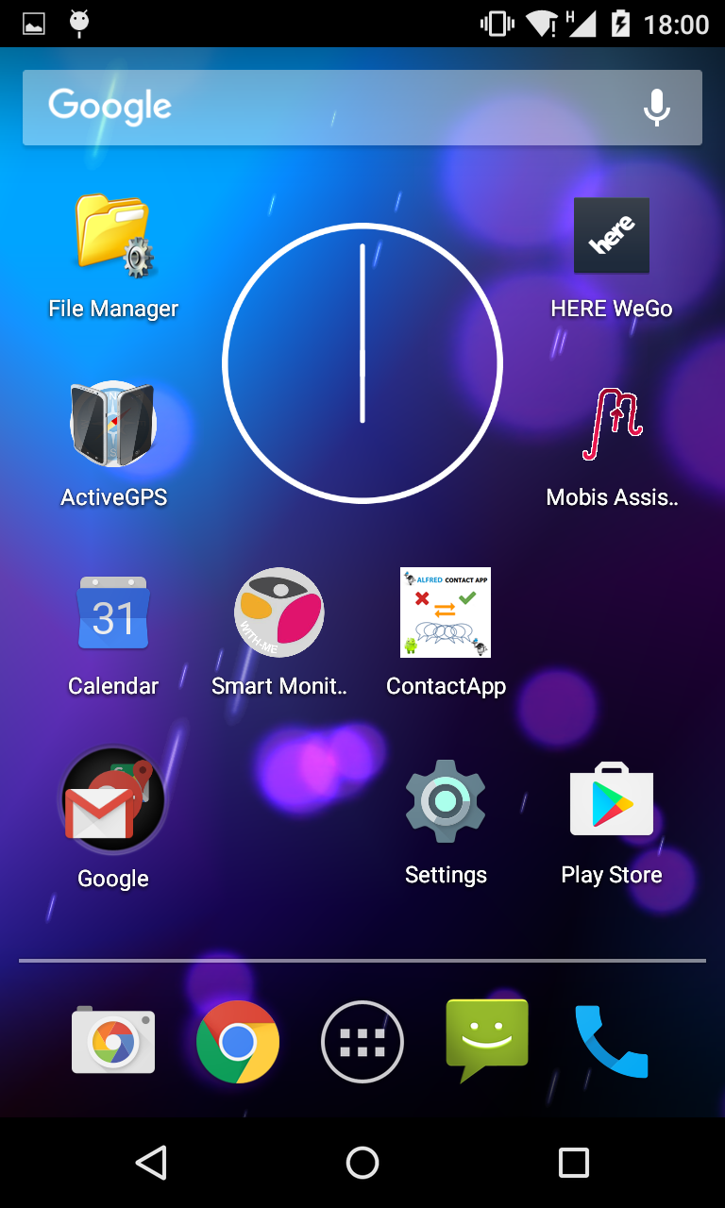 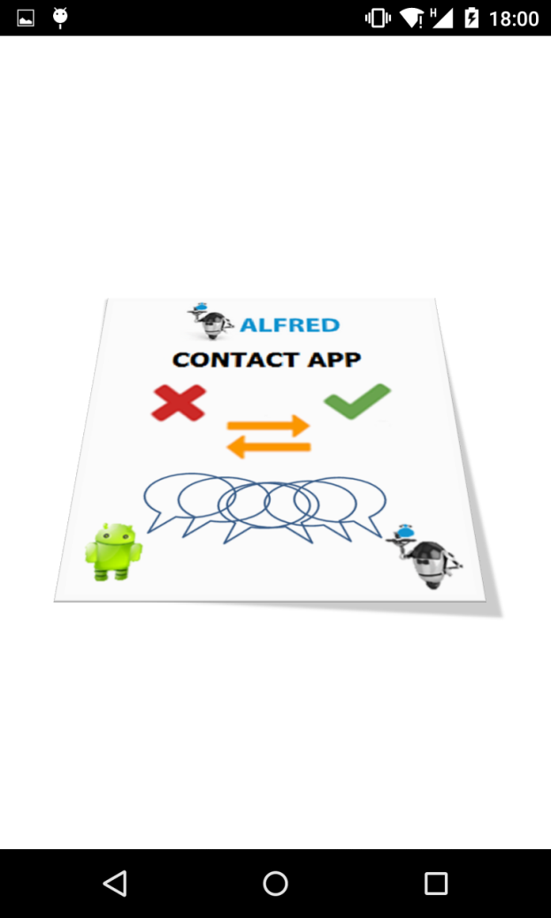

Internally, the application is checking permissions and accessing the shared capabilities of Alfred.

Two kind of contacts books are shown, as shown in the mock-ups. The left column shows Android native contacts, while the right column shows Alfred contacts.

A spinner is shown while the lists are being retrieved. Also, this view can be refreshed by the usual swipe refresh over the list, by sliding the finger from the top of the list.

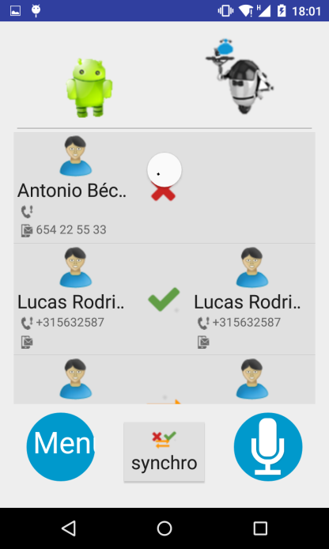

#### Interface and behaviour

The main screen shows this aspect. Basically, two parallel columns. Some contacts are paired here depending on the similarity of the data the contact has:

* If everything is the same, the paired contacts are evaluated as C:\DATOS\git_TUNNEL\alfredeu\contactapp\app\src\main\res\drawable\contacts_ok.png
* If it is possible that the contacts could be the same, they are evaluated as C:\DATOS\git_TUNNEL\alfredeu\contactapp\app\src\main\res\drawable\contacts_mapper.png
* If the contact hasn’t got a candidate to be paired, it is evaluated as C:\DATOS\git_TUNNEL\alfredeu\contactapp\app\src\main\res\drawable\contacts_ko.png

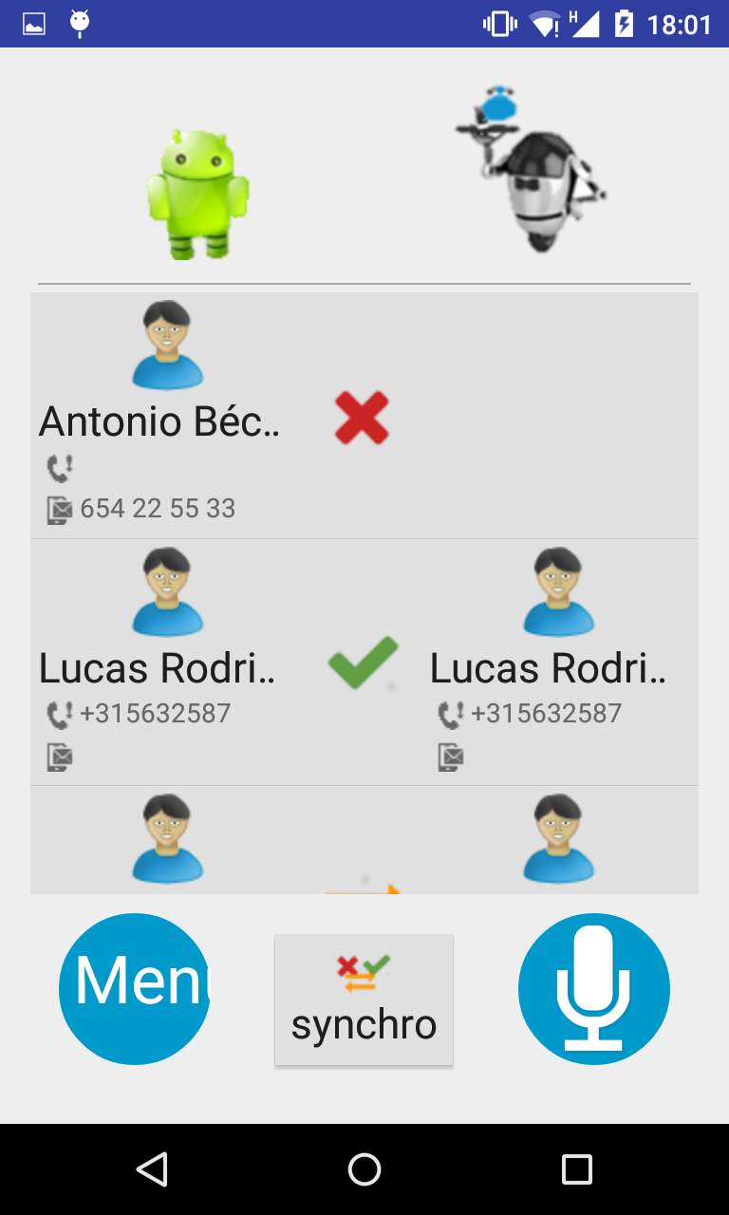

Scrolling for long fields

Mapping result

Alfred contacts

Android contacts

Swipe down to refresh

User can interact with the application in this ways:

* 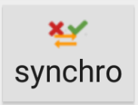   
  All contacts that are not present in the other system will be created. So Android contacts with an C:\DATOS\git_TUNNEL\alfredeu\contactapp\app\src\main\res\drawable\contacts_ko.png on the right and Alfred contacts with an C:\DATOS\git_TUNNEL\alfredeu\contactapp\app\src\main\res\drawable\contacts_ko.png on the left, will be inserted in Alfred and Android, respectively. This will be a batch of operations, a progress indicator will show how the proccess is being executed.  
  User will have to check individually contacts paired and marked as C:\DATOS\git_TUNNEL\alfredeu\contactapp\app\src\main\res\drawable\contacts_mapper.png.
* 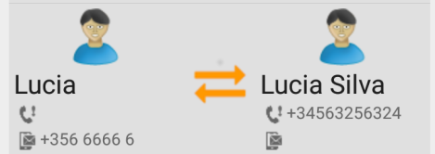  
  A pair of contacts that the app considers could refer to the same contact are show with a C:\DATOS\git_TUNNEL\alfredeu\contactapp\app\src\main\res\drawable\contacts_mapper.png symbol that opens a new activity and permits the manual mapping of the contacts.
* 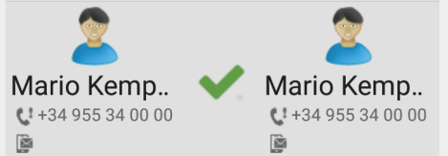  
  A pair of contacts that are present in both systems does not provide any behaviour, so selecting C:\DATOS\git_TUNNEL\alfredeu\contactapp\app\src\main\res\drawable\contacts_ok.pngwill have no effect.
* 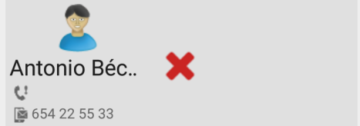  
  When a contact only appears in one of the systems, selecting the C:\DATOS\git_TUNNEL\alfredeu\contactapp\app\src\main\res\drawable\contacts_ko.png symbol will open a new activity that lets the user add the contact individually to the other system, if he does not want to perform a full contacts synchronization.

#### Synchronize all

When selecting this command, a confirmation dialog will ask for the operation to be done. Clicking in the button or by voice command, the user can accomplish this.

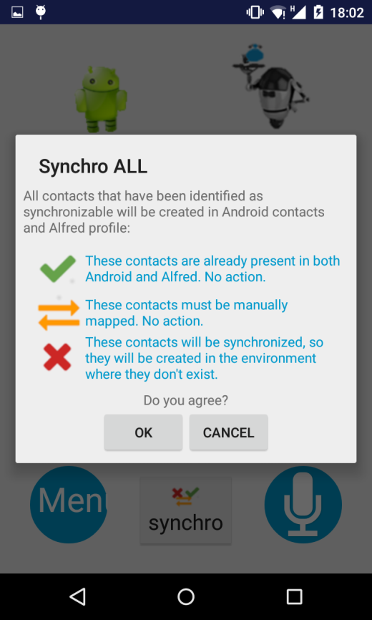

#### Manual mapping

When the application has found a potential pair of similar contacts, the user can specify if contacts are the same or different.

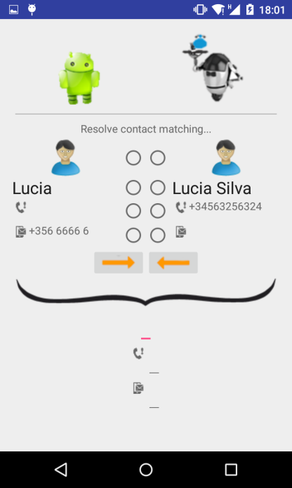

In case they are different, the contact can be directly exported to the other platform by selecting the arrows for exportation:



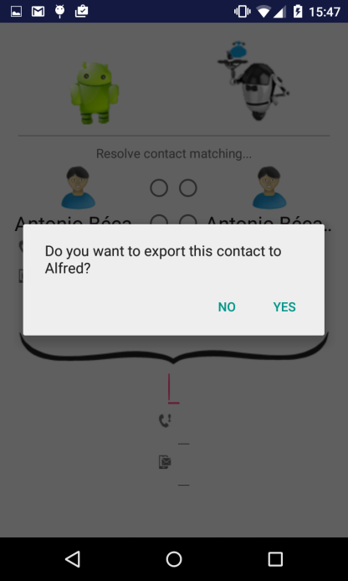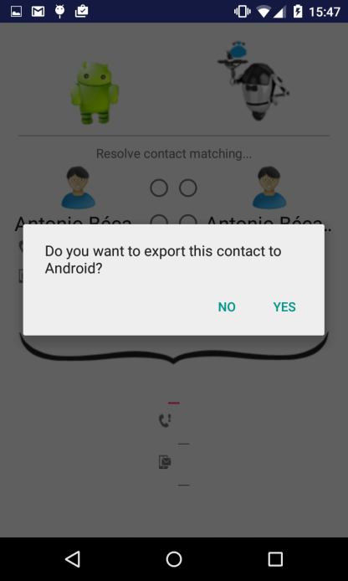

Otherwise, if the user wants to manually build a new resulting contact by mixing or changing the information provided by the paired contacts, it can be done in editing fields.

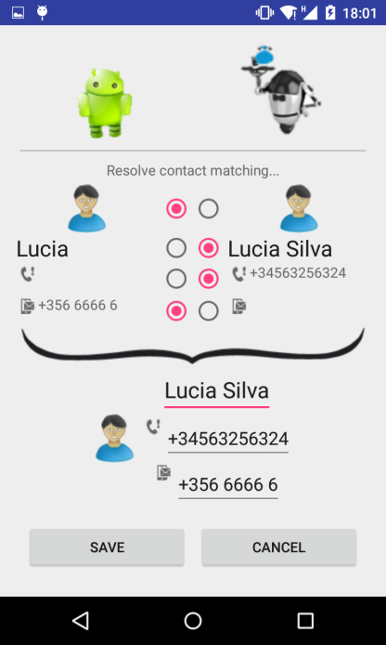

The contacts will be updated instead of created.

#### Single contact export

When selecting a contact that was not paired, user can export it individually to the platform in which the contact doesn’t exist.

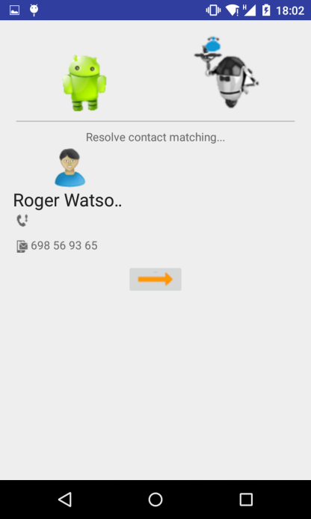 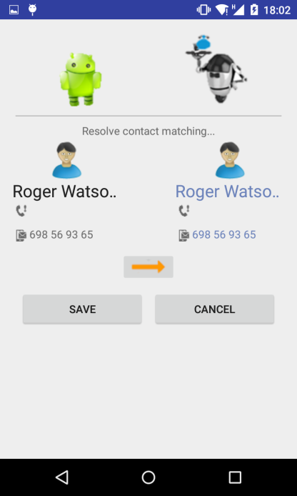

If the user saves the contact, there will be a new pair of contacts in the main view with the red mark.

### Code

Code can be found in <http://alfred.eu:9292/thardes/contactapp> master branch.

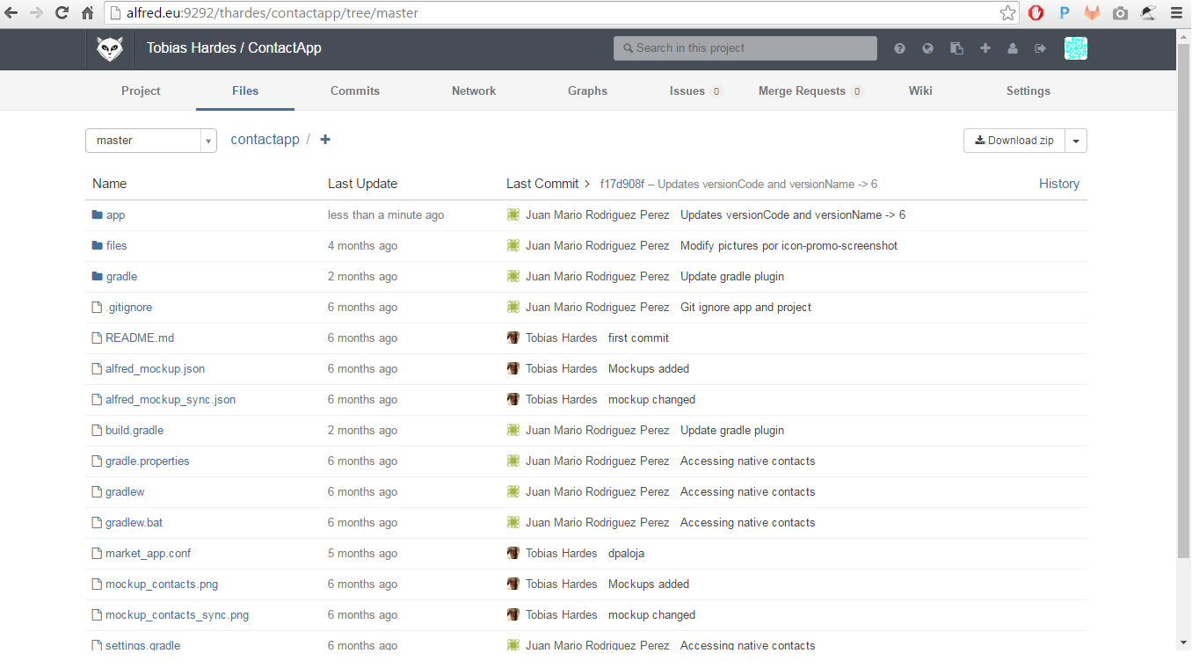

### Future work

Some aspects of ContactApp can be improved:

#### Translations

Edit the file strings.xml in contactapp\app\src\main\res\value.

|  |
| --- |
| <resources>  <string name="app\_name">ContactApp</string>  <string name="mapper\_title">Resolve contact matching...</string>  <string name="save">Save</string>  <string name="cancel">Cancel</string>  <string name="back">Back</string>  <string name="ok">Ok</string>  <string name="do\_you\_agree">Do you agree?</string>  <string name="phone">Phone</string>  <string name="mobile">mobile</string>  <string name="avatar">avatar</string>  <string name="result">result</string>  <string name="android">android</string>  <string name="alfred">alfred</string>  <string name="different\_contact">Different contacts</string>  <string name="same\_contact">Same contact</string>  <string name="map\_contact">Map contact</string>  <string name="synchro">synchro</string>  <string name="synchro\_all">Synchro ALL</string>  <string name="synchro\_finished">Contacts synchronized!</string>  <string name="synchro\_message">All contacts that have been identified as synchronizable will be created in Android contacts and Alfred profile:</string>  <string name="contacts\_ok\_action">These contacts are already present in both Android and Alfred. No action.</string>  <string name="contacts\_mapping\_action">These contacts must be manually mapped. No action.</string>  <string name="contacts\_ko\_action">These contacts will be synchronized, so they will be created in the environment where they don\'t exist.</string>  <string name="export\_to\_android">Do you want to export this contact to Android?</string>  <string name="export\_to\_alfred">Do you want to export this contact to Alfred?</string>  <string name="confirmation\_yes">Yes</string>  <string name="confirmation\_no">No</string>  <string name="error\_native">Error getting native contacts</string>  <string name="error\_alfred">Error getting Alfred contacts</string>  <string name="error\_contact">Error geting contacts</string>  <string name="error">Error</string>  </resources> |

#### Speech recognition

A couple of actions have been created in Android, ContactsComparisonAction and SynchroAllContactsAction. The corresponding files for cade are pending, grammars and interaction tests.

#### Avatars

Avatars in Android contacts boos are supported, but they are not considered as a field in ContactApp, neither compared with Alfred contacts.